Ethan Grunewald

St10365776  WEDE5020 POE Part 2

Prosperity Circles

Contents

Idea 2

Explanation of Choice: 2

Research 3

What is the issue? 3

Why is there so much poverty in the world? 3

Content. 4

ASSETS 4

Images 4

Websites 8

Improvements from Part 1 9

# Idea

The idea for POE Website: Prosperity Circles

Prosperity Circles is a compassionate online platform that enables individuals and businesses to give back to underserved communities and help alleviate poverty.

## Explanation of Choice:

The Prosperity Circles initiative aims to make a tangible impact on poverty by leveraging the collective efforts of individuals and businesses. It provides a structured and organized approach to giving back and enables people to contribute to causes they are passionate about. By connecting users with reputable nonprofits and focusing on collaborative projects, the platform can address immediate needs while also fostering sustainable solutions. The idea aligns with my commitment to social responsibility and my desire to make a positive difference in the lives of those facing poverty. Before proceeding, I will seek my lecturer's approval to ensure the feasibility and potential impact of the Prosperity Circles initiative.

Ensuring children have access to clean water is one of World Vision’s top solutions to poverty. Safe water close to home can protect children from water-borne diseases, and free them from long, often dangerous treks to fetch water. This gives them more time to be in school, learning. Societies with greater gender equality enjoy more sustainable development and faster economic growth. Empowered women are role models for girls in their communities. And they are more likely to send their own daughters to school.

According to the World Health Organization, eliminating malnutrition is one of the most cost-effective solutions to poverty. The developmental, economic, social, and medical impacts of malnutrition are serious and lasting. It affects individuals as well as their families, communities, and countries. Nourishing babies and young children is one of the best ways to fight poverty. Doing so in this critical window can improve children’s well-being for a lifetime – not just as survivors. But as students, earners, and leaders.

The number of people globally who live near conflict has doubled since 2007, according to The World Bank. That’s critical to know. Because in regions where conflict is prevalent, repeated cycles of violence and turbulence often keep families trapped in poverty.

# Research

## What is the issue?

Poverty is a multifaceted challenge characterized by lacking necessities like food, shelter, and healthcare. It encompasses issues such as inadequate education, limited employment opportunities, gender inequality, and social exclusion. Impoverished individuals and communities often face health disparities, environmental vulnerability, and a cycle of generational poverty. Discrimination and marginalization can further exacerbate the effects of poverty, particularly among vulnerable groups. Addressing poverty necessitates comprehensive strategies that encompass education, healthcare, social safety nets, and economic development, along with efforts to raise awareness and advocate for policy changes that promote equitable opportunities and improved living conditions for all.

## Why is there so much poverty in the world?

Poverty has multiple root causes beyond just a lack of basic necessities like food, shelter, education, or healthcare. Discrimination based on gender or ethnicity,

poor governance, conflict, exploitation, and domestic violence are all factors that contribute to this. These inequities trap people and communities in poverty, and limit access to social

services that could help people overcome it. Fragile contexts, which can be entire countries or regions, tend to be the most entrenched. Political instability, past or present conflicts,

corrupt leaders, and poor infrastructure limit access to necessities people need to thrive.

Poverty can be a trap that is difficult to escape. Without opportunities for clean water, healthcare, education, and financial resources, it can turn into a cycle that persists for generations.

When families lack the means to send their children to school, their children struggle to earn an income as adults. When communities lack access to clean water, women and girls spend many hours each day gathering water,

leaving little time for school or a livelihood. When medical facilities are far away, families lose income if they take time off work to care for sick loved ones.

Natural disasters and conflict can exacerbate this cycle, putting vulnerable communities at even greater risk. When natural disasters strike in areas without strong public institutions, families may lack the resources to recover, thus further entrenching them in poverty.

# Content.

## ASSETS

### Images

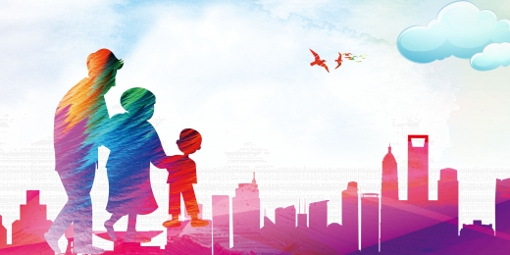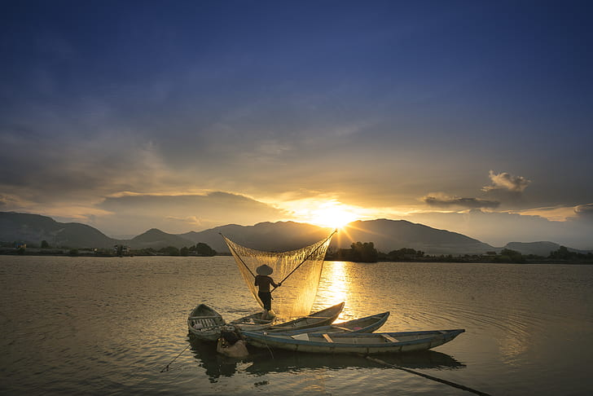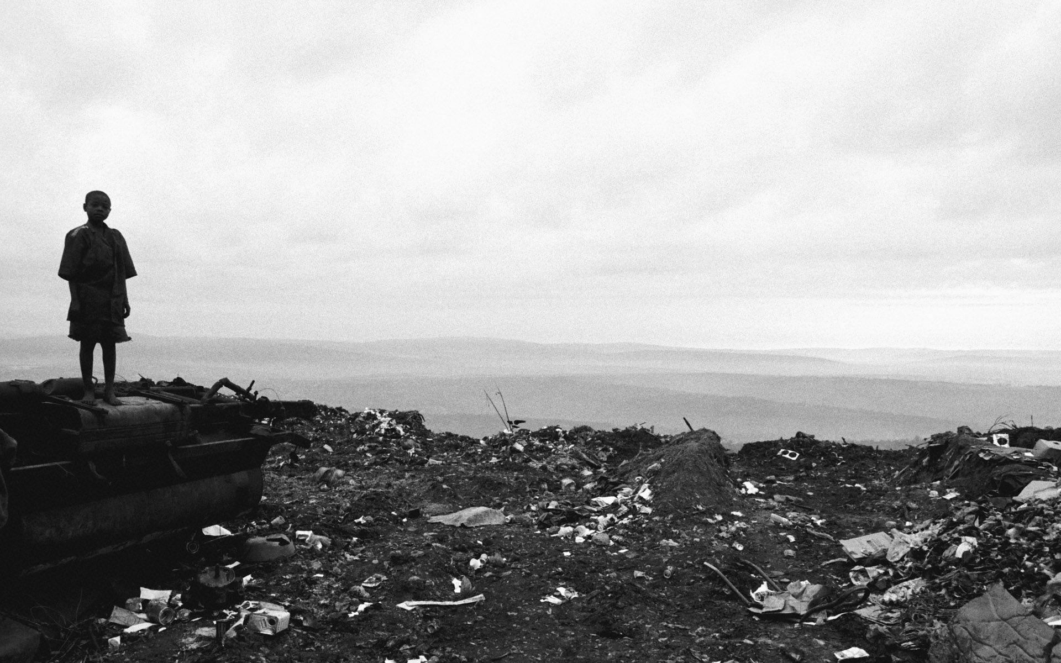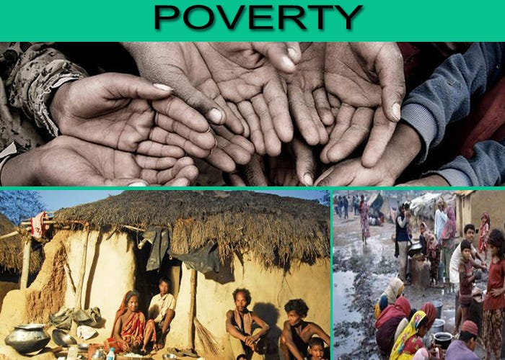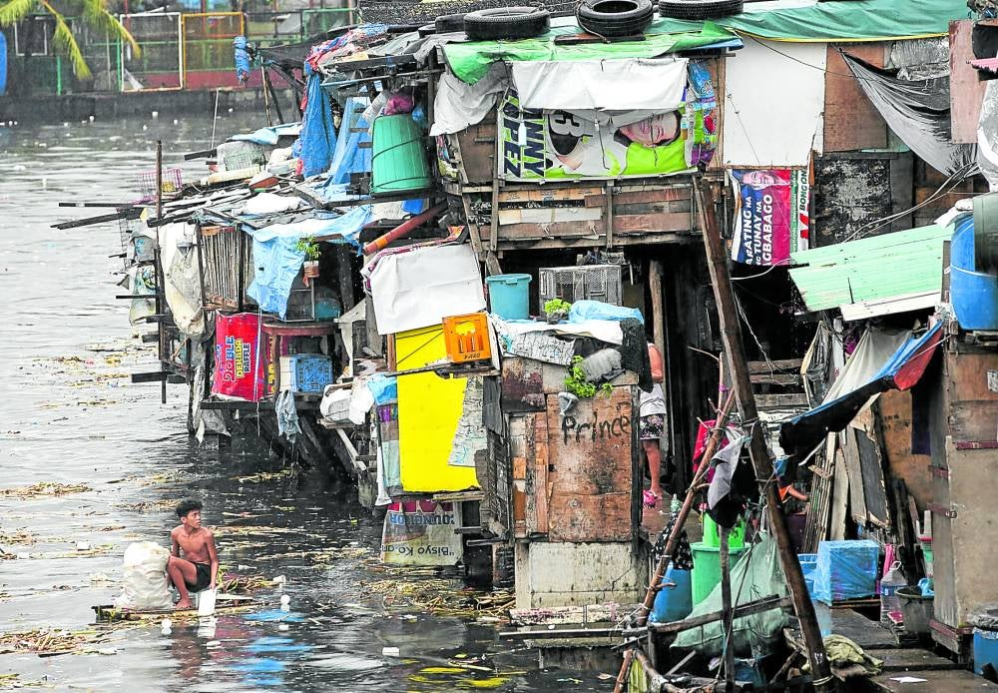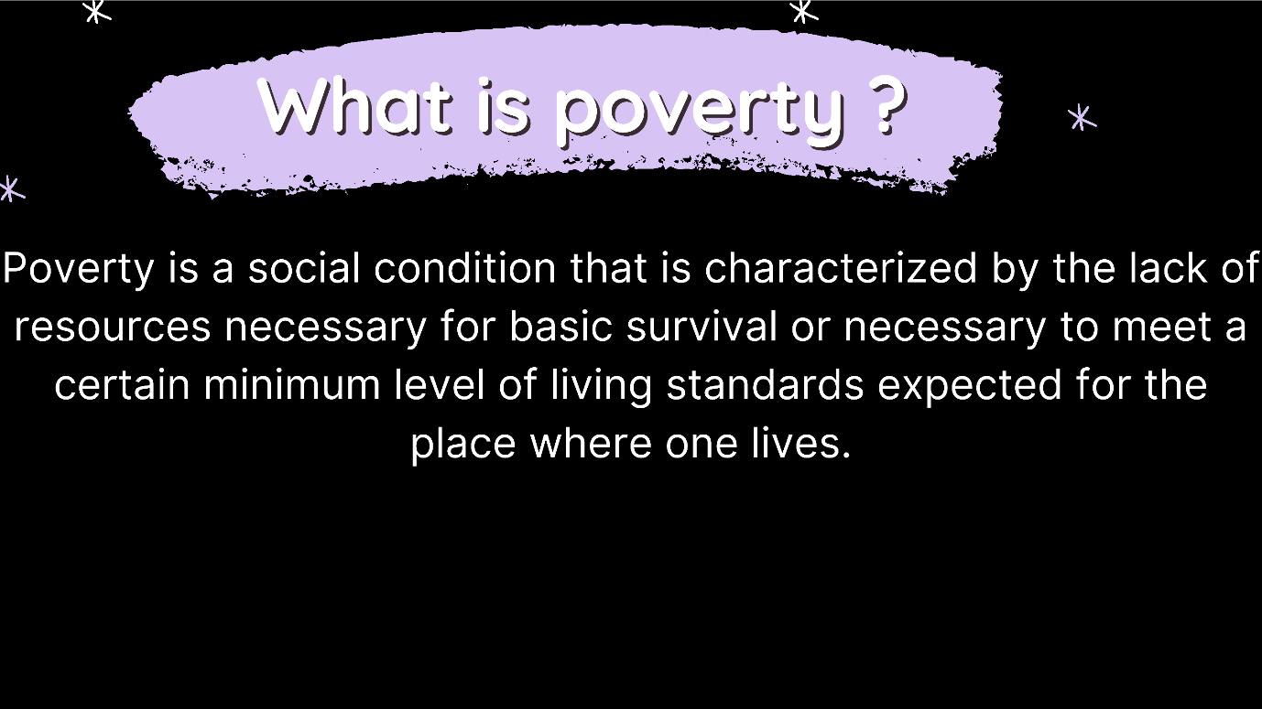

### Websites

<https://www.worldbank.org/en/topic/poverty/overview>

<https://reliefweb.int/report/world/11-top-causes-global-poverty>

<https://www.worldvision.ca/stories/advocacy/solutions-to-poverty>

# Improvements from Part 1

* In part 2 I added a new page called Their Story.
* The page is describing how one person went through poverty and the many challenges he had to face.
* I put the text into columns and then made a border over it and filled the background white.
* Made the buttons white, by changing the class name to correspond in the css file.

## Home page improvements

* I took the internal styling and created a css file, where I put my styling in there.

## Help us out improvements.

* Made the external website wider and longer, for more visibility.
* I took the internal styling and created a css file, where I put my styling in there.

## Contact us improvements.

* I took the internal styling and created a css file, where I put my styling in there.

## About us improvements.

* I took the internal styling and created a css file, where I put my styling in there.
* Made all the characters bold, to stand out more.